IGRS ABSTRACT

Aim

Checkpoint kinase 2 (CHEK2) is an emerging tumor suppressor gene that plays a critical role in maintaining genomic stability and preventing DNA damage. It encodes the CHK2 protein, a serine/threonine kinase involved in DNA repair pathways and cell cycle regulation. CHK2’s importance is underscored by its participation in the cellular response to DNA damage as a central mediator in the DNA damage checkpoint pathway. Mutations in CHK2 have been linked to several cancers, including breast, colon, kidney, prostate, and thyroid, making it a promising target for cancer therapy.

Human CHK2 is a single-chain protein of approximately 65 kDa, composed of 543 amino acids. It contains three principal functional domains: The serine-glutamine (SQ) and threonine-glutamine (TQ) cluster domain (SCD), the forkhead-associated (FHA) domain, and the serine/threonine kinase domain (KD) (Cai et al., 2009; Ung et al., 2018; Zannini et al., 2014). The SCD domain is located at the N-terminus of CHK2, and its SQ and TQ motifs are phosphorylated by phosphoinositide 3-kinase–related kinases (PIKKs), such as ATM and ATR (Buscemi et al., 2006; Kim et al., 1999; Matsuoka et al., 2007; O’Neill et al., 2000). The FHA domain mediates interactions with phosphorylated proteins, including the phosphorylated SCD of another CHK2 molecule, and demonstrates high specificity for phosphorylated threonine(Almawi et al., 2017; Zannini et al., 2014). At the C-terminal of the protein there is a kinase domain (KD) between residues 213-501. The kinase domain (KD), located at the C-terminus (residues 213–501), adopts a typical Ser/Thr kinase fold consisting of an N-terminal lobe (residues 213–305), which is rich in β-sheets, and a larger, mostly α-helical, C-terminal lobe (residues 306–501). The ATP-binding site lies in the cleft between these two lobes (C lobe; residues 306-501) mostly α-helical (Cai et al., 2009).

Under normal conditions, CHK2 exists as an inactive monomer in the nucleus. Upon DNA double-strand breaks, CHK2 is phosphorylated by ATM, causing significant structural rearrangements that include homodimerization and A-loop phosphorylation upon ATP binding. These events lead to further conformational changes and subsequent dissociation of the CHK2 homodimer into fully active monomers, enabling CHK2 to carry out its DNA repair and cell cycle checkpoint functions effectively.

Molecular dynamics (MD) methods are widely used computational tools for investigating the structural and dynamic properties of proteins at atomic-level spatial and femtosecond-level temporal resolutions. MD simulations model the spatiotemporal behavior of all atoms within a molecular system—including proteins, surrounding water molecules, ions, and ligands—by utilizing physics-based force fields. These simulations provide detailed, real-time molecular insights that are often challenging to obtain through experimental methods alone. In this study, all-atom MD simulations were conducted to examine five point mutations located in the C-lobe of the kinase domain (KD) of CHK2: D438Y, R474H, R318C, R318H, and T476M (Akcay et al., 2021; Baloch et al., 2014; Kleiblová et al., 2019; Momozawa et al., 2018; Xie et al., 2018). The primary aim of these simulations and hence our study was to investigate how these specific mutations affect the structural stability and dynamic behavior of the CHK2 kinase domain, thus enhancing our understanding of their potential roles in tumorigenesis and cancer progression.

Material Method

To generate the active wild-type (WT) CHK2 structure, an initial structural model for MD simulations was created by integrating structural information obtained from the crystal structures with PDB identifiers 3I6U (Cai et al., 2009) and 2CN5 (Oliver et al., 2006). Specific residues (S379, T383, T387, and T389) within the activation loop of CHK2 were phosphorylated. Moreover, an ADP molecule, two Mg²⁺ ions, and crystallographic water molecules extracted from the 2CN5 structure were incorporated into the model. Structures carrying mutations (D438Y, R474H, R318C, R318H, and T476M) were generated using the Mutator plugin in VMD (Humphrey et al., 1996). All structures were solvated in a TIP3P water box with padding dimensions of 28 Å (x-axis), 20 Å (y-axis), and 28 Å (z-axis). Systems were neutralized, and ionic concentrations were set to 210 mM KCl and 20 mM NaCl. All systems were prepared by using VMD.
All simulations were carried out in NAMD 3.0 (Phillips et al., 2020), and CHARMM36 all-atom additive protein force field (Best et al., 2012). A 12 Å cutoff was applied for van der Waals interactions, and a 2 fs time step was used. Long-range electrostatic interactions were calculated using the particle-mesh Ewald (PME) method. The simulations were run under NPT conditions at 310 K and 1 atm. Temperature was maintained using Langevin dynamics with a damping coefficient of 1 ps⁻¹, and pressure was controlled via the Langevin Nosé-Hoover method with an oscillation period of 100 fs and a damping time scale of 50 fs.
To assess structural stability and flexibility differences between mutant and WT CHK2 proteins, Root Mean Square Deviation (RMSD) (Phillips et al., 2020) and Root Mean Square Fluctuation (RMSF) (Karplus & McCammon, 2002) analyses were performed. RMSD measures the average structural deviation of atoms from a reference structure over the simulation trajectory, quantifying overall conformational stability. RMSD is calculated using the formula:
$$RMSD(t)=\sqrt{\frac{1}{N}\sum_{i=1}^{N}{{\left(r_{i}\left(t\right)-r_{i}\left(0\right)\right)}^{2}}}$$

where N represents the total number of atoms considered, rᵢ(t) denotes the position of atom i at time t, and rᵢ(ref) is the position of atom i in the reference structure. Higher RMSD values indicate greater structural deviations from the initial conformation.
RMSF measures the local flexibility and dynamic behavior of individual atoms or residues over the course of the simulation. RMSF is defined as:
$$RMSF= \sqrt{\frac{1}{T}\sum_{t=1}^{T}{{\left\|r_{i}\left(t\right)- 〈r_{i}〉\right\|}^{2}}}$$

where T represents the total number of trajectory frames analyzed, rᵢ(t) is the position of atom i at time t, and ⟨rᵢ⟩ is the average position of atom i over the entire simulation period. Higher RMSF values reflect increased flexibility or movement, while lower values indicate structural rigidity.
Both RMSD and RMSF calculations enabled comparison of mutant and WT CHK2 proteins, providing valuable insights into how the studied mutations may influence the structure, stability, and dynamic properties of the CHK2 kinase domain. For the RMSD and RMSF analyses, only the coordinates of C_{α} atoms were considered. The reference structure is the initial build CHK2 protein structure that was build as a combination of crystal structures having PDB IDs 3I6U and 2CN5.

Findings

Two independent sets of MD simulations, each lasting 300 ns, were performed for every mutant. RMSD and RMSF analyses were conducted separately for each MD trajectory. From RMSD analyses (Figure 1), the D438Y, T476M, and R474H mutants showed higher RMSD values compared to the WT CHK2 protein, suggesting structural deviations compared to WT.

RMSD

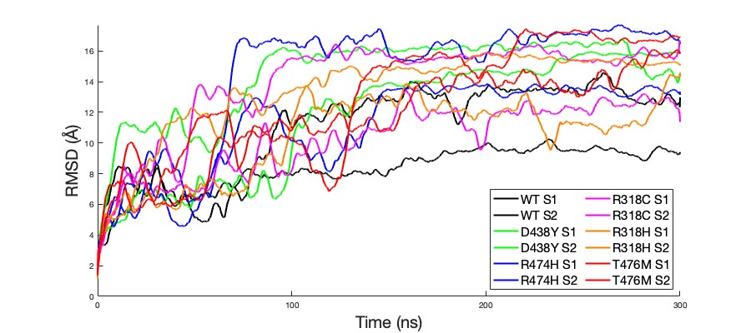
Figure 1: RMSD calculations of mutant and wild type proteins

Figure 2 shows the RMSF analysis of WT and mutant CHK2 proteins. The R318H mutant exhibited reduced RMSF values between residues 96 and 160. Similarly, in the residue range 208–266, the R318H and T476M mutants demonstrated lower RMSF values compared to WT. Within the residue range 257–264, the R318C mutant showed increased RMSF, whereas the other mutants (R474H, D438Y, R318H, and T476M) exhibited decreased RMSF values. Additionally, in the residue range 371–391, all mutants displayed higher RMSF values relative to the WT. Overall, the R318H mutant displayed consistently lower RMSF values throughout the entire protein compared to the other mutants.
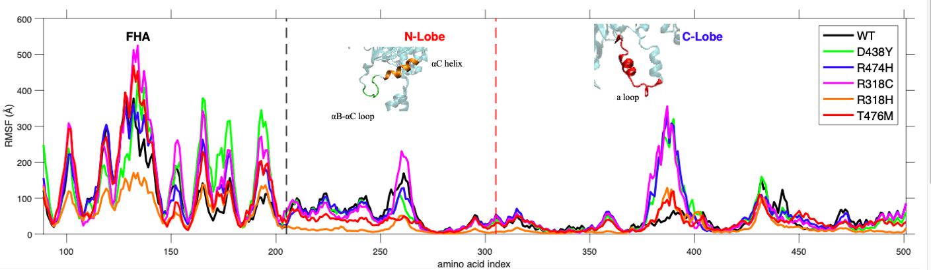
Figure 2: RMSF calculations of wylde type and mutant proteins

Conclusion

This study utilized all-atom MD simulations to investigate the structural and dynamic consequences of five cancer-associated point mutations (D438Y, R474H, R318C, R318H, and T476M) located in the C-lobe of the CHK2 kinase domain. RMSD analyses indicated that the D438Y, T476M, and R474H mutations induced considerable structural deviations, which may impact protein stability and function. Furthermore, distinct alterations in protein dynamics were also observed through RMSF analysis. In particular, the R318H mutant displayed pronounced dynamic changes throughout nearly the entire protein structure. All five mutations altered RMSF profiles compared to WT CHK2, with notable changes concentrated in the residue ranges 257–264 and 371–391. Within the residue range 208–266, the R318H and T476M mutants exhibited greater dynamic alterations than the other studied mutants. Collectively, these simulations highlight how specific mutations in the CHK2 kinase domain’s C-lobe can profoundly influence protein structure and dynamics. These findings provide molecular insights into potential mechanisms through which CHK2 variants may contribute to cancer progression, contributing to guiding future experimental validation and informing potential therapeutic strategies.

References

Akcay, I. M., Celik, E., Agaoglu, N. B., Alkurt, G., Kizilboga Akgun, T., Yildiz, J., Enc, F., Kir, G., Canbek, S., Kilic, A., Zemheri, E., Ezberci, F., Ozcelik, M., Dinler Doganay, G., & Doganay, L. (2021). Germline pathogenic variant spectrum in 25 cancer susceptibility genes in Turkish breast and colorectal cancer patients and elderly controls. International Journal of Cancer, 148(2), 285–295. https://doi.org/10.1002/IJC.33199
Almawi, A. W., Matthews, L. A., & Guarné, A. (2017). FHA domains: Phosphopeptide binding and beyond. Progress in Biophysics and Molecular Biology, 127, 105–110. https://doi.org/10.1016/J.PBIOMOLBIO.2016.12.003
Baloch, A. H., Daud, S., Raheem, N., Luqman, M., Ahmad, A., Rehman, A., Shuja, J., Rasheed, S., Ali, A., Kakar, N., Naseeb, H. K., Mengal, M. A., Awan, M. A., Wasim, M., Baloch, D. M., & Ahmad, J. (2014). Missense mutations (p.H371Y, p.D438Y) in gene CHEK2 are associated with breast cancer risk in women of Balochistan origin. Molecular Biology Reports, 41(2), 1103–1107. https://doi.org/10.1007/S11033-013-2956-X
Best, R. B., Zhu, X., Shim, J., Lopes, P. E. M., Mittal, J., Feig, M., & MacKerell, A. D. (2012). Optimization of the additive CHARMM all-atom protein force field targeting improved sampling of the backbone φ, ψ and side-chain χ(1) and χ(2) dihedral angles. Journal of Chemical Theory and Computation, 8(9), 3257–3273. https://doi.org/10.1021/CT300400X
Buscemi, G., Carlessi, L., Zannini, L., Lisanti, S., Fontanella, E., Canevari, S., & Delia, D. (2006). DNA damage-induced cell cycle regulation and function of novel Chk2 phosphoresidues. Molecular and Cellular Biology, 26(21), 7832–7845. https://doi.org/10.1128/MCB.00534-06
Cai, Z., Chehab, N. H., & Pavletich, N. P. (2009). Structure and Activation Mechanism of the CHK2 DNA Damage Checkpoint Kinase. Molecular Cell, 35(6), 818–829. https://doi.org/10.1016/J.MOLCEL.2009.09.007
Humphrey, W., Dalke, A., & Schulten, K. (1996). VMD: Visual molecular dynamics. Journal of Molecular Graphics, 14(1), 33–38. https://doi.org/10.1016/0263-7855(96)00018-5
Karplus, M., & McCammon, J. A. (2002). Molecular dynamics simulations of biomolecules. Nature Structural Biology 2002 9:9, 9(9), 646–652. https://doi.org/10.1038/nsb0902-646
Kim, S. T., Lim, D. S., Canman, C. E., & Kastan, M. B. (1999). Substrate specificities and identification of putative substrates of ATM kinase family members. The Journal of Biological Chemistry, 274(53), 37538–37543. https://doi.org/10.1074/JBC.274.53.37538
Kleiblová, P., Stolařová, L., Křížová, K., Lhota, F., Hojný, J., Zemánková, P., Havránek, O., Vočka, M., Černá, M., Lhotová, K., Borecká, M., Janatová, M., Soukupová, J., Ševčík, J., Zimovjanová, M., Kotlas, J., Panczak, A., Veselá, K., Červenková, J., … Kleibl, Z. (2019). Germline CHEK2 Gene Mutations in Hereditary Breast Cancer Predisposition - Mutation Types and their Biological and Clinical Relevance. Klinicka Onkologie : Casopis Ceske a Slovenske Onkologicke Spolecnosti, 32(Supplementum2), 2S36-2S50. https://doi.org/10.14735/AMKO2019S36
Matsuoka, S., Ballif, B. A., Smogorzewska, A., McDonald, E. R., Hurov, K. E., Luo, J., Bakalarski, C. E., Zhao, Z., Solimini, N., Lerenthal, Y., Shiloh, Y., Gygi, S. P., & Elledge, S. J. (2007). ATM and ATR substrate analysis reveals extensive protein networks responsive to DNA damage. Science (New York, N.Y.), 316(5828), 1160–1166. https://doi.org/10.1126/SCIENCE.1140321
Momozawa, Y., Iwasaki, Y., Parsons, M. T., Kamatani, Y., Takahashi, A., Tamura, C., Katagiri, T., Yoshida, T., Nakamura, S., Sugano, K., Miki, Y., Hirata, M., Matsuda, K., Spurdle, A. B., & Kubo, M. (2018). Germline pathogenic variants of 11 breast cancer genes in 7,051 Japanese patients and 11,241 controls. Nature Communications, 9(1). https://doi.org/10.1038/S41467-018-06581-8
Oliver, A. W., Paul, A., Boxall, K. J., Barrie, S. E., Aherne, G. W., Garrett, M. D., Mittnacht, S., & Pearl, L. H. (2006). Trans-activation of the DNA-damage signalling protein kinase Chk2 by T-loop exchange. The EMBO Journal, 25(13), 3179–3190. https://doi.org/10.1038/SJ.EMBOJ.7601209
O’Neill, T., Dwyer, A. J., Ziv, Y., Chan, D. W., Lees-Miller, S. P., Abraham, R. H., Lai, J. H., Hill, D., Shiloh, Y., Cantley, L. C., & Rathbun, G. A. (2000). Utilization of oriented peptide libraries to identify substrate motifs selected by ATM. The Journal of Biological Chemistry, 275(30), 22719–22727. https://doi.org/10.1074/JBC.M001002200
Phillips, J. C., Hardy, D. J., Maia, J. D. C., Stone, J. E., Ribeiro, J. V., Bernardi, R. C., Buch, R., Fiorin, G., Hénin, J., Jiang, W., McGreevy, R., Melo, M. C. R., Radak, B. K., Skeel, R. D., Singharoy, A., Wang, Y., Roux, B., Aksimentiev, A., Luthey-Schulten, Z., … Tajkhorshid, E. (2020). Scalable molecular dynamics on CPU and GPU architectures with NAMD. The Journal of Chemical Physics, 153(4), 044130. https://doi.org/10.1063/5.0014475
Xie, Y., Li, G., Chen, M., Guo, X., Tang, L., Luo, X., Wang, S., Yi, W., Dai, L., & Wang, J. (2018). Mutation screening of 10 cancer susceptibility genes in unselected breast cancer patients. Clinical Genetics, 93(1), 41–51. https://doi.org/10.1111/CGE.13063
Zannini, L., Delia, D., cell, G. B.-J. of molecular, & 2014, undefined. (n.d.). CHK2 kinase in the DNA damage response and beyond. Academic.Oup.Com. Retrieved November 23, 2024, from https://academic.oup.com/jmcb/article-abstract/6/6/442/2886260

